For the Visegrad4 project, I would like to leave my usual perspectives and go to other points of view. My educational journeys are important to me in order to open my eyes. During each of these trips I try to find „the red thread“: the one that occupies me the most in my surroundings. In notes I reach for these red threads - to recognize and hold them.

Travel notes:
Indien 2017 | Budapest 2017 | Prag 2018
Vietnam 2018 | Marseille 2018 | 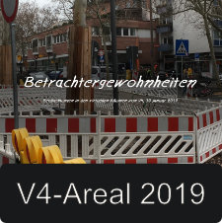Mainz 2019
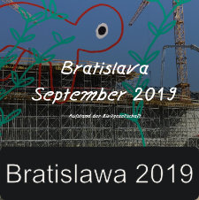Bratislawa 2019

