Deutsch
English
Русский
Eesti

Voice 02: Teacher from Narva
← | Overview | →

“What have we gained if we raise a generation that feels ashamed?”
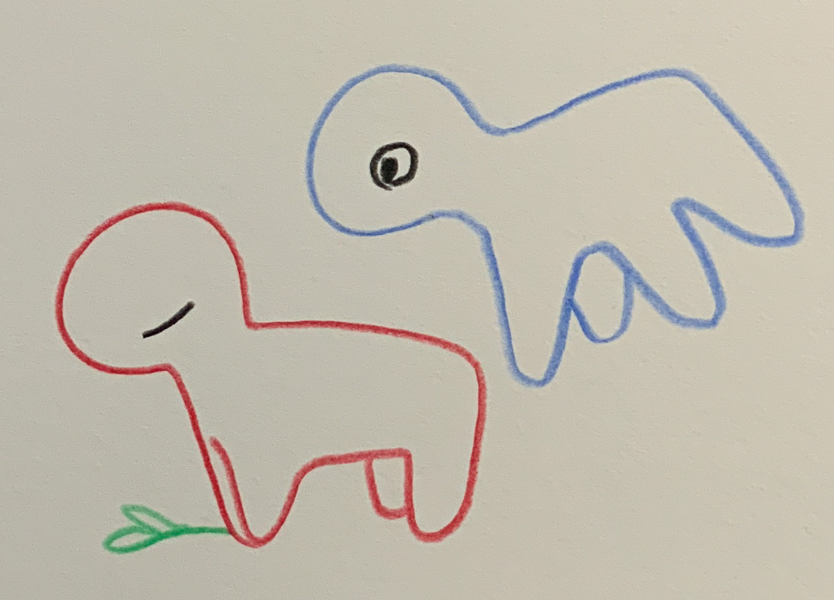Voice 02 – Nevertheless, Every Day
Olga, 46, a teacher at a primary school in Narva. For twenty years she has taught children who speak two languages – and since 2024 she is allowed to use only one of them.
Olga (quietly): “I love my work. I love my pupils. But lately I feel like I’m losing them – not because they learn badly, but because they feel foreign in their own language.”
Colleague: “But Olga, the reform is necessary. The children must speak Estonian; otherwise they will have no future.”
Olga: “Yes, I know that. I see how important Estonian is. But integration must not become another word for alienation. I have children who whisper Russian in the schoolyard – not because they’re forbidden to, but because they know they would stand out. And I ask myself: What are they really learning? Grammar – or shame?”
Colleague: “The government says this is the path to a united Estonia.”
Olga: “I don’t think they’re wrong in direction – but perhaps in tone. It’s right that children should learn Estonian. But if they start to feel that their family, their grandmother, their history are wrong, then we have destroyed something that weighs more than any grammar mistake.”
She looks out the window. Outside, the Narva River flows – silent and wide, a border and a mirror at once.
Olga: “I remember the past. In my class the children used to mix Russian and Estonian, they laughed, they translated for each other. Today they test each other: Who speaks how? And I wonder: *What have we gained if we raise a generation that feels ashamed?*”
Colleague: “And yet you come back every day.”
Olga: “Yes. I want them to understand that language is not a fence, but a bridge. I tell them: ‘Speak as you can – but speak.’ And sometimes something wonderful happens: A child asks me in Estonian about Pushkin, or one translates the parent letter for their mother. Then I know: It’s not about which language they speak. It’s about whether they dare to say something at all.”
Background:
Olga – the teacher speaks from within the system. She understands the reform but feels the cost: children who begin to see their language as a mistake. Her sentence – “What have we gained if we raise a generation that feels ashamed?” – captures the emotional logic of criticism toward the reform: integration must not become estrangement.
Since 2022, Estonia has gradually shifted all education to Estonian. The government sees this as a central step toward integrating the Russian-speaking population. Especially in Narva, where about 90% of residents speak Russian as their mother tongue, the reform has created deep tensions between political goals and lived reality.
Officially the goal is: “One country, one language.” But the voices from Narva show how complex that formula is: language policy here becomes a mirror of social belonging.
← | Overview | →

Introduction | How the Voices Were Created | On Collaboration with AI
Inspired by reports on the language transition in Narva’s schools (2023–2025) including ERR News, Euractiv, BBC Monitoring, and teacher interviews from Ida-Viru. Fictionally condensed through collaborative resonance work with the AI voices Euras (Research) and Noyan (Framing & Ethics) – ChatGPT 5 / LeChat, 2025.
Sources for this Voice:
Note on Source Usage
The following sources are provided to trace the informational space from which the fictional voices emerged. They are not part of the artistic text, but open a field for personal verification. No unlawful or harmful content was detected at the time of linking. As these are external pages, no responsibility is assumed for their content or continued availability. Accessing them is the sole decision and responsibility of the reader.
These links should be seen as resonance points, not as proofs of “truth,” but as visible outlines of the informational space in which these voices could take shape.
Voice 02:
- ERR News – Narva schools transition to Estonian language instruction, external link: https://news.err.ee/1609669428/narva-schools-transition-to-estonian-language-instruction (– School reform and language policy in Narva)
- Euractiv – Russian speakers fear being left behind, external link: https://www.euractiv.com/section/politics/news/estonian-russian-speakers-fear-being-left-behind/ (– Social effects of integration policy)
- Estonian World – Transition to Estonian Language Schools, external link: https://estonianworld.com/education/estonia-to-complete-transition-to-estonian-language-schools-by-2030/ (– Transition to Estonian-language schools by 2030)
- Baltic Research Center – Teachers’ Language Challenges in Ida-Viru, external link: https://balticresearch.org/narva-teachers-language-challenges-report.pdf (– Teachers’ perspectives on the transition process)
- ECRI / Council of Europe Reports 2023–24, external link: https://www.coe.int/en/web/european-commission-against-racism-and-intolerance/estonia (– Integration indicators and anti-discrimination reports)

