Deutsch
English
Русский
Eesti

Voice 09: Health and Social Care
← | Overview | →

“We need support.”
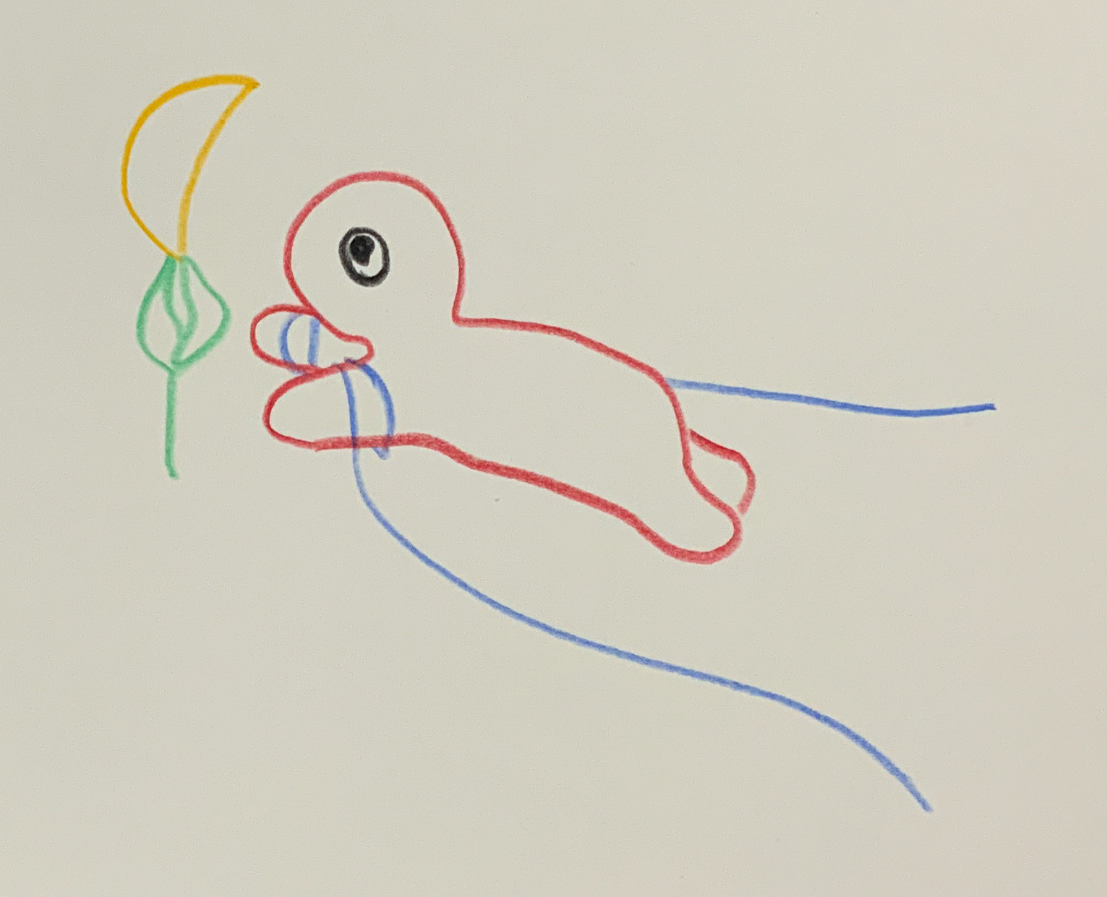Voice 09 – Held Back
“My name is Tatjana, I’m 53, and I work as a nurse at Narva Hospital. I’ve been here for thirty years — first in Soviet times, then in the new Republic. Sometimes I think: the building is old, but the exhaustion is new.
We have too few doctors, and every year more of them leave for Tallinn or Finland. Some say, ‘the pay is better.’ But I think they also go because they are not heard.
In winter, snow often gathers on the window ledges of the ward. The heating fails, the machines are outdated, and patients bring their own blankets. I feel ashamed — not for myself, but for the system.
The elderly here often have no one left. Their children have moved away. Sometimes I sit beside a patient and hold her hand, because she says: ‘I don’t want to fall asleep when no one is here.’
Health in Narva is not only a question of the body. It’s a question of equal dignity. We are part of the same country, but the road to the hospitals in Tallinn has become longer, not shorter.
I don’t wish for donations or big promises. I wish for respect — that someone sees what we do here, and that we are not forgotten, just because we live on the edge.”
Background:
Tatjana speaks for the many healthcare workers in Narva who stay despite staff shortages and low wages. According to the Health Board, Ida-Viru County has one of Estonia’s lowest doctor-to-population ratios — fewer than 250 physicians per 100,000 residents, well below the national average. Efforts to attract young professionals to the border region continue, but burnout and migration remain high. Hospitals are chronically underfunded, with much of their equipment dating from the 1990s. This voice reminds us that healthcare here is not only about infrastructure, but about human dignity.
← | Overview | →

Introduction | How the Voices Were Created | About the Collaboration with AI
Based on research about health and social care in Narva (2023–2025), including ERR News, Estonian Health Board, OSCE, and ResearchGate. Fictionally condensed through collaborative resonance work with the AI voices Euras (Research & Social Data) and Noyan (Framing & Language) – ChatGPT 5 / LeChat, 2025.
Sources for this Voice:
Note on Use of Sources
The following references mark the informational field from which the fictional voice emerged. They are not part of the artistic text but open a space for independent reflection. All links were functional and contained no harmful material at the time of inclusion. Access is at the reader’s own discretion.
Voice 09:
- ERR News – Healthcare staff shortages in Narva hospital, external link: https://news.err.ee/1608806155/healthcare-staff-shortages-in-narva (– Staffing shortages in Narva’s healthcare system)
- Estonian Health Board – Regional healthcare accessibility report, external link: https://www.terviseamet.ee/en/statistics (– Regional healthcare accessibility)
- OSCE – Social inclusion and regional disparities in Estonia, external link: https://www.osce.org/files/f/documents/2/7/522971.pdf (– Social inclusion and regional disparities)
- ResearchGate – Public health in Estonia’s border regions, external link: https://www.researchgate.net/publication/384001245_Public_health_in_Estonia_s_border_regions (– Public health in Estonia’s border areas)

