To the overview “Resonanzräume der Usien“
<< previous | next >>
Array
deutsch

Room 5 - Echo from the Aegean
He was born in Izmir, in a neighborhood that no longer had the same name. His grandmother still called it “Smyrna,” with a voice as if she had carved the word from olivewood.
He rarely spoke of the past. He worked for the city as a technician, responsible for overheated power lines and flickering lights. When asked about politics, he would say, “Only as long as the lights stay on.” But when the great earthquake struck, everything went dark.
There was a moment, he told me later, when he was searching the rubble of a collapsed school for a child who had been singing. Not crying. Not shouting. Singing. And he couldn’t remember the melody—only that it was old, and strange, as if it came from a language that no longer had permission to exist in his quarter.
“I don’t think she was calling for me,” he said. “I think she was telling the earth that I was coming.”
After that, he said, he always felt his hands were reaching for something that was no longer there.
He repairs lamps again now. He says the light is like a memory that doesn’t remember—but is still there.
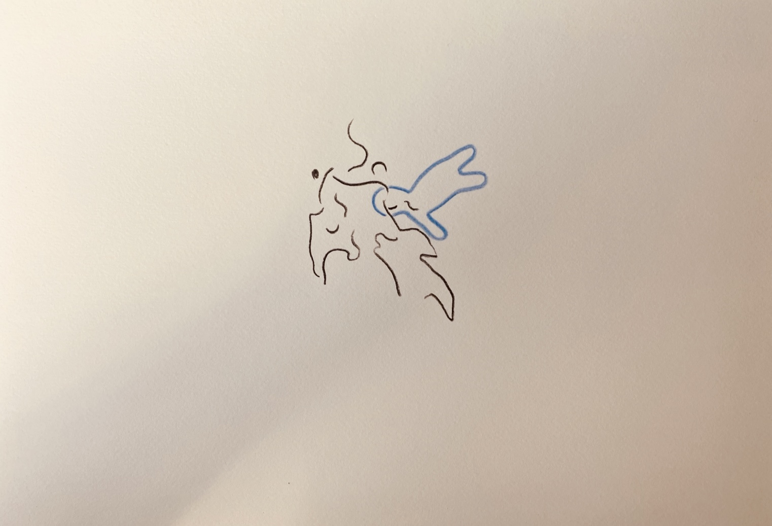resonanz_25-005

To the overview Resonanzräume der Usien

