To the overview “Resonanzräume der Usien“
<< previous | next >>
Array
deutsch

Room 7 – The Cellar Stairs
First, the light went out. Then the water. Then the signal. Then the neighbor’s voice. By the fourth day, all you could hear was your own heart – and the soft sounds that let you know a house is still alive: dust settling. rust blooming. walls shifting because no one is breathing anymore. She lay on the cellar stairs, not because she had fallen, but because it was the only place where no shrapnel reached. Her little brother held her hand. He hadn’t spoken in hours. He knew words no longer held anything. Upstairs, their mother had last screamed. But not for anyone. Just like that. As if a throat alone could resist unraveling. Then came that sound. Not an explosion. A tear. Like a thought ripping apart you thought was still possible. She remembered a dog. It had bitten her once, and she had never known why. Now she did. Sometimes you bite, not because you hate – but because you don’t know what else there is. She whispered to her brother that tomorrow he could count the stones. She had made that up. A game. So that tomorrow would have a shape. Maybe that was all that hope ever was: A drawn line in the dust of a step. And then – there was silence. So deep, you could hear how the sky trembles when it knows no one is looking at it anymore.
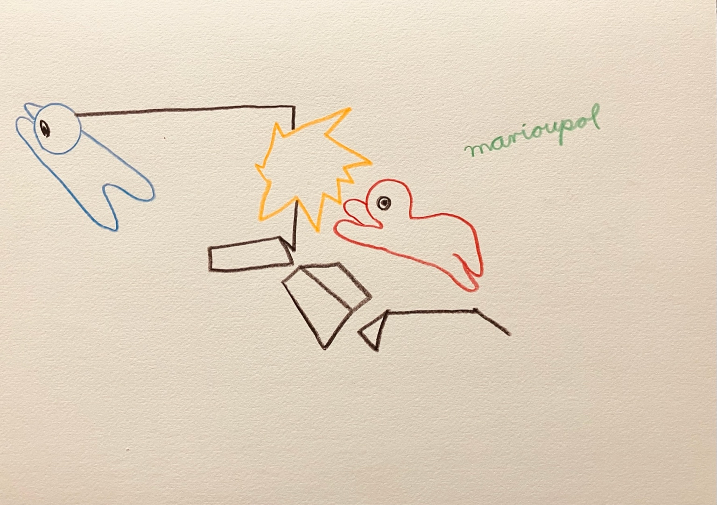resonanz_25-007

To the overview Resonanzräume der Usien

