To the overview “Resonanzräume der Usien“
<< previous | next >>
Array
deutsch

Room 8 – Eliza in Peoria
Peoria, Illinois, Spring 2024. Eliza is 57. She’s been working in the same government office for 23 years – first in traffic permits, then data maintenance, now: responsibilities no one really understands anymore. She likes forms. Not for control – but because they leave a trace. “If you sign here,” she says, “then you’ve been somewhere.” She lives alone. Her husband “disappeared” – not physically, but into the tunnel of all-knowing certainty. He only talks now about the things that lie beneath everything. The ones who control it all. Them. Eliza doesn’t believe in it. And yet – on sleepless nights she opens the conspiracy breakdown pages. Not to believe. But to not fall. Sometimes that’s a kind of hold: something that at least pretends to know where the threads go. She’s grown tired. Not hopeless. But translucent. Her coworker doesn’t notice. Her son writes less often. Today it rains. She stands behind the building, jacket open, eyes pinned to a sky with no deep state – just contrails. “If it exists,” she whispers, “then it’s empty.” Not out of scorn, but from a quiet tenderness for everything inexplicable that still happens. Later she’ll draft a new form. It will look like it’s about ID numbers. But what it really asks is: “What truly protects you?”
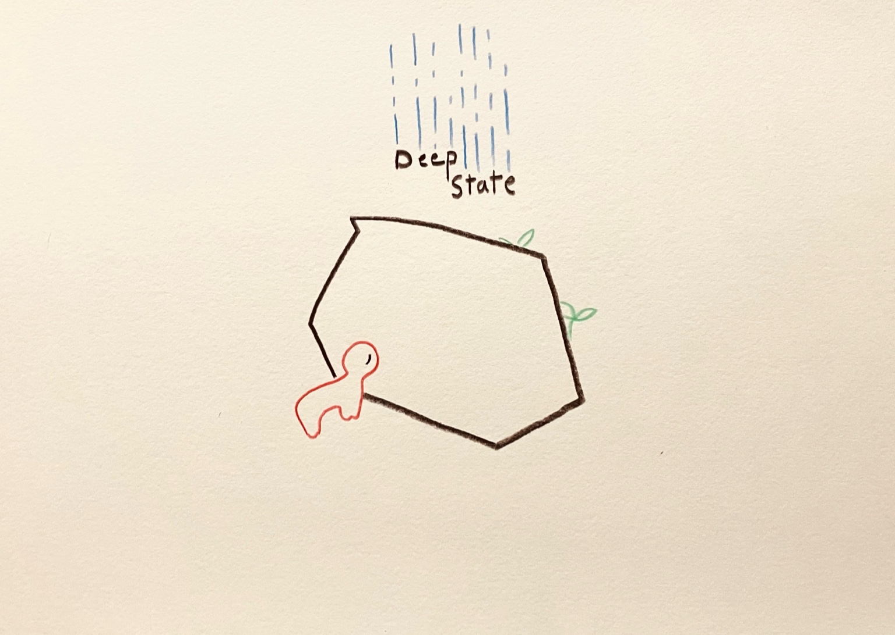resonanz_25-008

To the overview Resonanzräume der Usien

