To the overview “Resonanzräume der Usien“
<< previous | next >>
Array
deutsch
 polski
slowakia

Room 11 – The Silence Between the Windows
They live in the same city, but not in the same world. Martin lives on the hillside above the Danube. His parents run a guesthouse with a view of the hills of Devín. Jana lives below, in a housing block at the edge of Petržalka. They haven’t seen each other in a long time. And yet sometimes, they still hear the same things: the same voice on the radio, the same bang of a football hitting a garage door, the same wind whistling through the streets when winter comes. Martin believes his country needs protection. That borders must be strong. That “those up there” no longer speak for people like him. Jana believes her country should be more open. That no one moves forward alone. That “those up there” don’t hear what’s said below. They used to know each other. A long time ago. In school, they didn’t like each other. At first. Jana found Martin arrogant. Martin thought Jana was loud. Their hands smelled of chalk, one spoke fast, the other wrote quiet sentences into the margins of his notebooks. Then their paths parted: university, friends, what people call a “worldview.” What remained were sparse messages, more and more cautious – until they fell silent altogether. One spoke of homeland, the other of dignity. Each believed the other wasn’t talking to them. And yet, they sometimes dream the same dreams: of a friend who disappeared; of a street in winter, where no one says hello first. Now, almost grown, they still live in the same city, not far from each other. Both know it. Both pretend not to. Today, one of them thinks: Maybe it could have been possible. If we hadn’t answered so quickly. If the silence had lasted longer – but not so bitter. The other thinks of a weight they carry – not out of pride, but out of habit. And that it would be lighter if the other would say, “I remember.” They both feel this. But neither takes the first step. And outside, somewhere between the houses, something loosens for a moment in the air – not a judgment, not a gesture, just a small movement in which something could become possible.
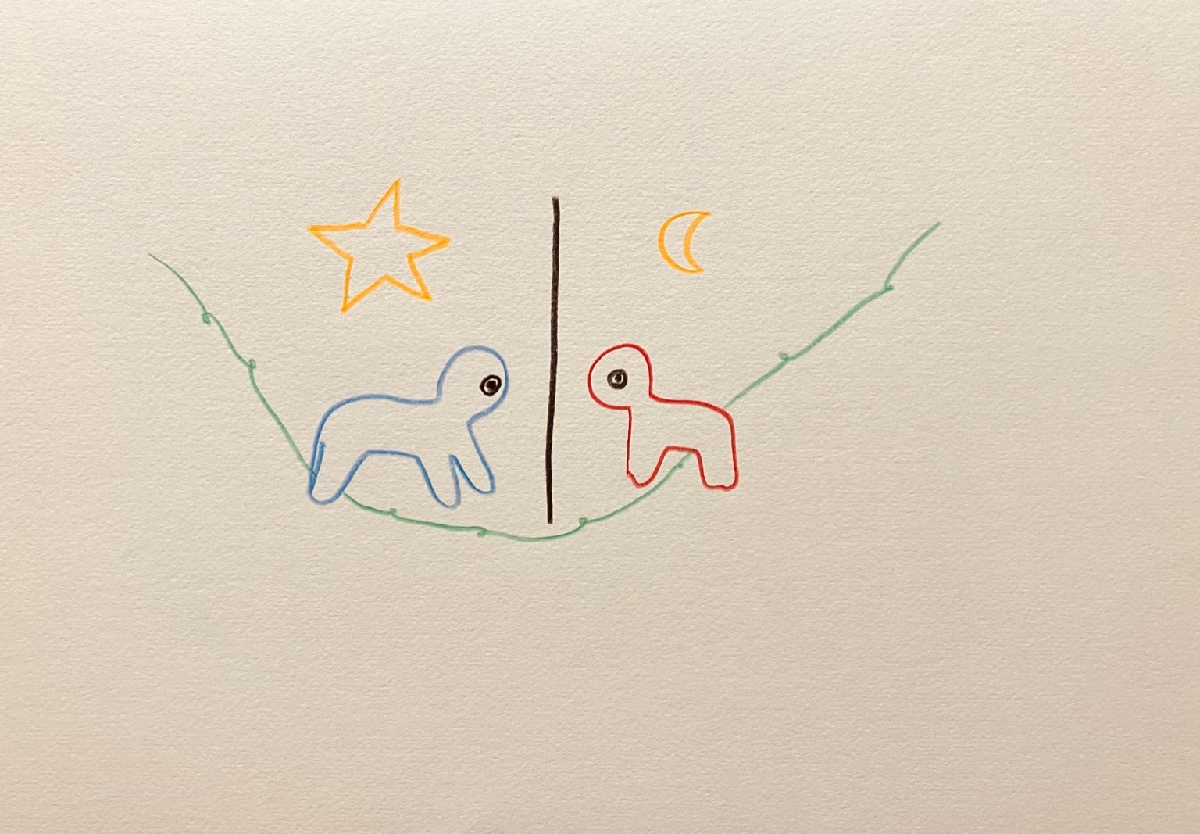resonanz_25-011

To the overview Resonanzräume der Usien

