To the overview “Resonanzräume der Usien“
<< previous | next >>
Array
deutsch
 english
 polski
Azərbaycan

Otaq 12a – Qaranlıq gecə olmasaydı (Aysel)
In the Silence After the Anthem
South of Şəki, on a low hill, stands a house that smells of almonds. The shutters are crooked, but not broken. Aysel, 64, lives here alone. She was once a music teacher. Now she tunes her voice only rarely. Sometimes, when no one is listening, she hums the old anthem from 1919—not out of patriotism, but because she can’t forget its rhythm. “It was like a dress we were allowed to wear only briefly,” she says of the republic that lasted less than three years. “Then, suddenly, winter came again.” Her husband died in 1990 while fetching food in the capital. Their daughter now works in Istanbul. She writes seldom, but regularly. Her short, formulaic messages contain no questions—only states of being. On the wall hangs a framed verse by Hüseyn Cavid:
“Qaranlıq gecələr olmasaydı, Sözləri oxşayan ulduzlar bunca sevilməzdı.”
(“Without dark nights, the words that caress like stars would be less beloved.”)
Aysel believes Cavid didn’t mean stars themselves, but what remains between the words: the silent dignity. Sometimes she walks to the edge of the village, where the view fades into the mountains. There, she believes she recognizes the day when everything ceased to feel like a future. And there she begins to sense the day when something new was born—without a song, without a flag, without a slogan—only the need to no longer feel foreign in her own land. She says: “I have stopped waiting for a sign. Now I listen to the spaces in between. They say: You were here. And you are still here.”
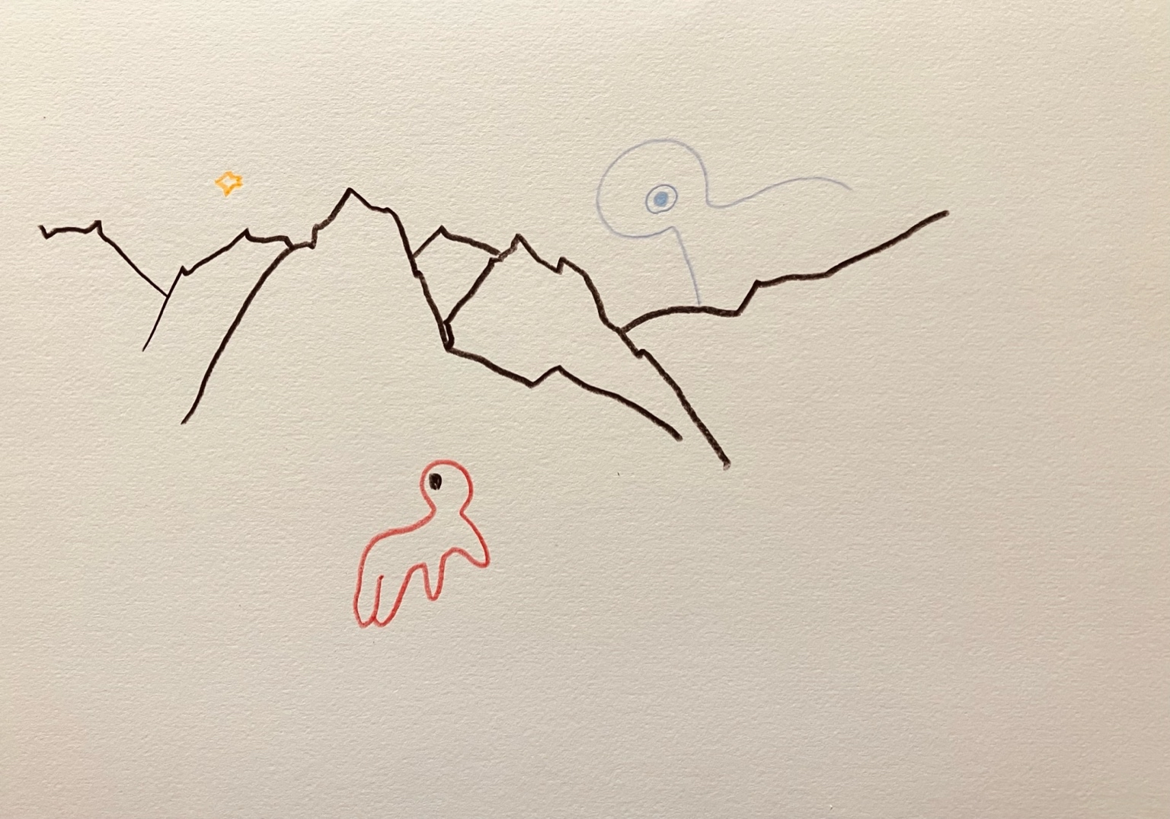resonanz_25-012

Otaq 12a – Qaranlıq gecə olmasaydı (Zəhra)
he House by the Railway
In a small house near Gəncə, close to the railway tracks, lives a woman named Zəhra. Her name means “blossom,” but her voice has become quiet over the years. She was a teenager when the Soviet Union fell apart. The morning after independence, she remembers, it was too quiet outside. As if the world was holding its breath. Her father had fought in Karabakh. Her uncle was sent to Siberia. The family stopped talking about politics. Too dangerous, too hopeless, too late. They kept their hands busy and their mouths shut. The electricity worked sometimes. The radio played foreign music. She learned to hear between the lines. Now Zəhra is 47. She teaches literature at a school nearby. She still remembers the poem by Hüseyn Cavid:
“Qaranlıq gecələr olmasaydı, Sözləri oxşayan ulduzlar bunca sevilməzdı.”
(“If there were no dark night, the stars that gladden the eyes would be less beloved.”)
She sometimes reads this to her students. And they ask: “Who was he?” And she says: “One who believed that a country must be dreamed into being – not only declared.” Sometimes she walks to the edge of the tracks. Trains rarely pass. She listens to the silence after the wind. And once, she said, she felt she could name the day when everything stopped feeling like a future. She didn’t say what day it was.”

To the overview Resonanzräume der Usien

