Zu den Reiseberichten
Array
deutsch

2023: Yerevan, Armenia
( 5 - 13 May 2023)
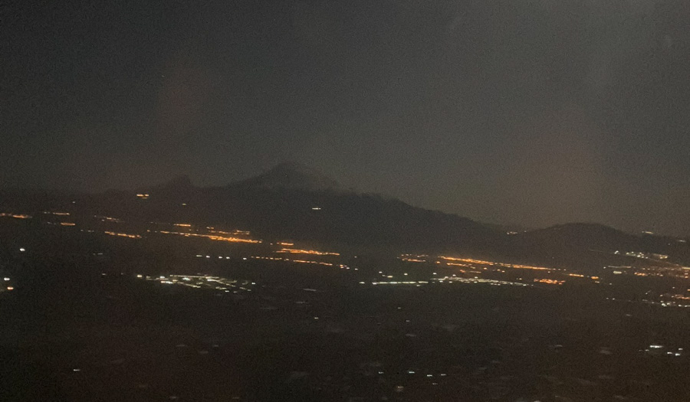

5 May, Departure
Last year in Azerbaijan, I had the feeling that the EU was a promise for people I met there, a distant destination to which getting there would solve all problems. Expectations of Europe were very high. Not so much in what Europe does for others. But rather as an inspiring utopia of a life in wonderful conditions. As if it were hardly possible that someone could not be relaxed and happy there, filled with a serious joy in the gift of their own freedom. At least, that's how I often felt in the East of the West. One would like to have that for oneself too, life in freedom, a distant dream. Slowly, a broad disillusionment sets in about the supposedly wonderful people of the West who appreciate the gift of their freedom. In Poland, this has been the case for a long time.
Here, on the plane, on the way to Armenia, the enemy of Azerbaijan in the conflict over Nagorno-Karabakh, the (I imagine) competitor for the „favour“ of the EU. This is something I would like to know here: Azerbaijan and Armenia are in the Council of Europe. Do they both want to be in the EU and is that somehow mutually exclusive? Azerbaijan is an authoritarian country. The Aliyev family decides on the big things, even if they allow a lot of freedom in the small ones. Also to keep the door to the EU open.
How is it in Armenia? It's a Christian country, that's a difference. But is there also something like an Aliyev family there that actually controls everything and that you don't mess with? And how significant is the affiliation with the Russian system and image of society?

7 May, city tour
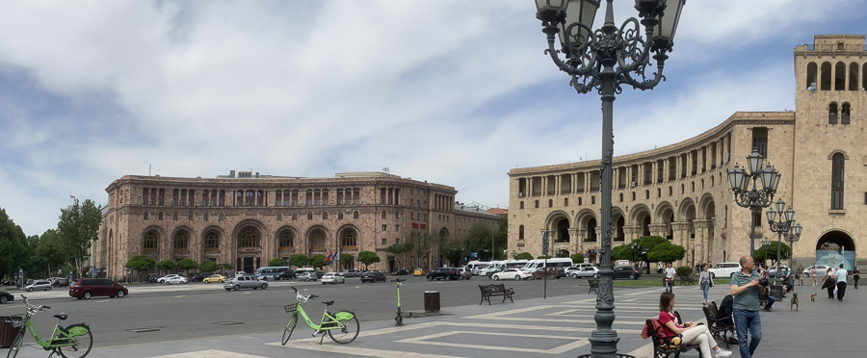
Our city guide tells Doris and me a lot about Yerevan and Armenia. She comes from this city. The name the Armenians call themselves „Haik“ is the name of an archer and mythological ancestor. In ancient Armenian it means „he who looks to the sky“. The Armenian language is directly rooted in Sumerian, the city guide is convinced. In the Soviet era, her family belonged to the educated class, self-confident and wealthy. Then came the Soviet collapse in 1991 with the radical capitalism that followed it. The roubles in the bank were suddenly worth nothing. There was no compensation for them either. You could not exchange them for Russian roubles Simply gone. In 1993, a new currency was introduced, the Armenian dram.
Some people in Armenia knew how to make use of the situation. Either because they were already corrupt before, or because they showed an unscrupulous talent for it. The people's assets were sold off among the families and friends of the powerful. New billion-dollar fortunes were created; now they say „the oligarchs“ to the profiteers from that period. Haik's descendants with less shrewdness and nefariousness plunged into economic nothingness. Many emigrated. The third beheading of Armenia, the city guide calls it. The first is the genocide in 1915, the second the Stalinist murders and expulsions around 1937. Of the 11 million native Armenian speakers in the world today, only 3 million live in Armenia. And look to heaven with their ancestor, seeking there the hope that is hard to find on earth.
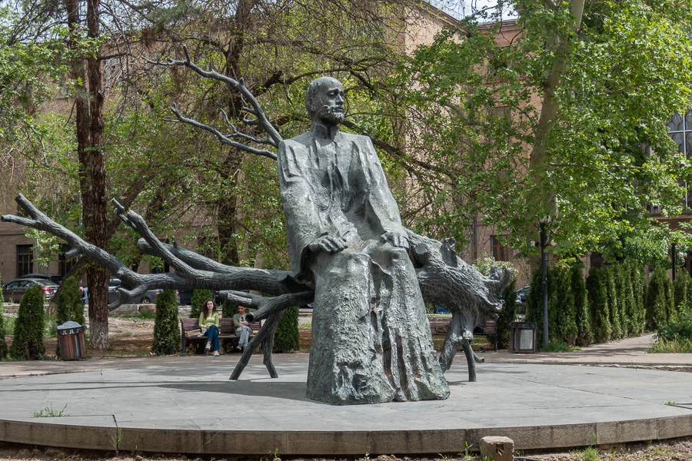
The many sculptures of musicians and artists in Yerevan also have this effect on me. For example, in front of the Conservatory of Music. With hands that seem to weave the spirit and eyes that are directed towards the higher world. Komitas Vardapet, who collected the traditional Armenian folk songs and then had to experience the genocide. A witness and survivor, he died in a mental hospital in France in 1935.

The Genocide
Here in Armenia was an origin of the modern systematic genocides. From 1915 to 1917, the declining Ottoman Empire tried to solve the so-called „Armenian question“ by wiping out the Armenian people. Along with its language, its culture, its monuments and its memory. The first victims were the Armenian soldiers serving in the Ottoman army. Then the intellectual elites. Then the defenceless rest. There are no words to express the horror, wrote contemporary observers.
How can something so immeasurably terrible be surpassed? The Stalinist Soviet Union demonstrated it with the Holodomor in 1932/33, the starvation murder of millions of Ukrainians. An atrocity that today's Russia is following up on. Russia today cites reasons similar to those of the Young Turks around 1915. They needed a secure buffer zone against the strong enemy, which at that time for the Turks in the Caucasus was Tsarist Russia. Whoever lives in this buffer zone must be loyal, if not, if not completely, he must disappear. As if he had never existed.
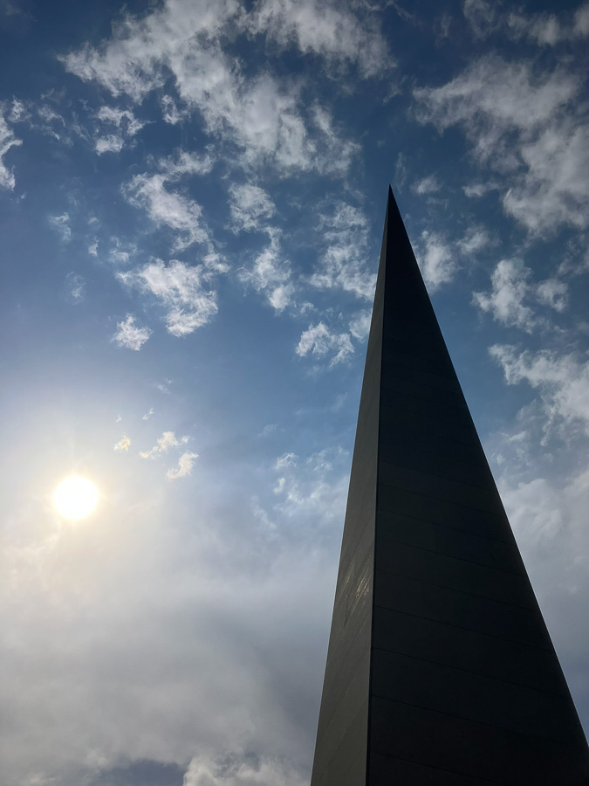
Adolf Hitler in Nazi Germany said in a dinner speech in 1937: „Who still talks about the annihilation of the Armenians today?“ referring directly to this genocide as if it were an encouraging example. You can get away with something like that when the interests of the world lie elsewhere. You can do it again.
The German Empire also let its Turkish ally have its way in 1915-17. Although the diplomats' reports were numerous and clear. This is how Armenia still experiences it today: injustice is done to it and no one intervenes. Turkey has never recognised the genocide, instead it sharply suppresses talking about it. There, the historical truth is an insult to Turkishness and a criminal offence. France, on the other hand, has made it a criminal offence to deny the genocide of the Turks against the Armenians. Germany recognised the genocide in 2016 with one vote against and one abstention in parliament. 100 years too late, but still. Today, Europe is still struggling to find a stance on this shame.

Western Armenia, today Eastern Anatolia
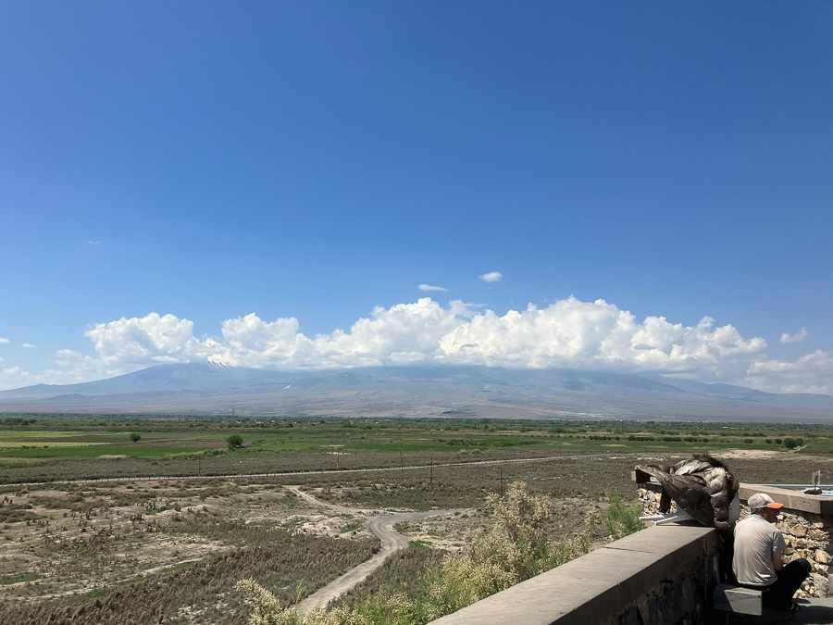
Today Ararat, Armenia's holy mountain belongs to Turkey. Lenin and Atatürk had divided the country between themselves in the turmoil between the world wars. Eastern Armenia became a Soviet republic and Western Armenia Turkish. Today it is called Eastern Anatolia. The surviving Armenians of the genocide were not asked. They were the plaything of the more powerful neighbours. Nevertheless, their language and culture survived both the Soviet Russification and the Turkish extermination attempt and the subsequent Soviet and Turkish re-educations. There is a great power of survival in the ancient Armenian culture. Even today. It resists authoritarian egalitarianism. Perhaps that is one reason why even today it has determined enemies (Azerbaijan and Turkey) but only half-hearted friends (Russia, Iran and the West). Armenia is small, alone and weak. That is how it must behave, despite all its pride.
Armenians who have become rich abroad have tried again and again to support their home country. First „Russia“ (the city guide uses that as a synonym for the Soviet Union) prevented that, then the first two corrupt governments of the Republic of Armenia.
In 2018, the „Velvet Revolution“ brought a new government to power. Nikol Pashinyan is now prime minister, and with him Armenia is attempting a new beginning. The corruption of the late Soviet era and the oligarchs is deep in the bowels of the state and the administration. It is a tough struggle. But some formerly corrupt officials are now afraid of getting caught and just do their job. Without raising a hand next to it. This is new. Even if it is still rare.

9 May, Victory Day
„Доброе утро“, „Dobre Utra“ sounds from all sides when the tour group of Russian youths enters the small breakfast room of the hotel in Yerevan in the morning. Today is 9 May, the day of the victory Victory over National Socialism, a public holiday in Russia and Armenia. In Moscow on Red Square, the traditional parade will take place. Perhaps a little more reduced than last year? Many cities in Russia, it was reported, had cancelled their victory parades. For fear of Ukrainian attacks. Putin talks about the peoples of the world who place their trust in freedom from oppression in Russia alone. There is pro-Russian sympathy in Armenia, the majority of TV channels show the Russian view.
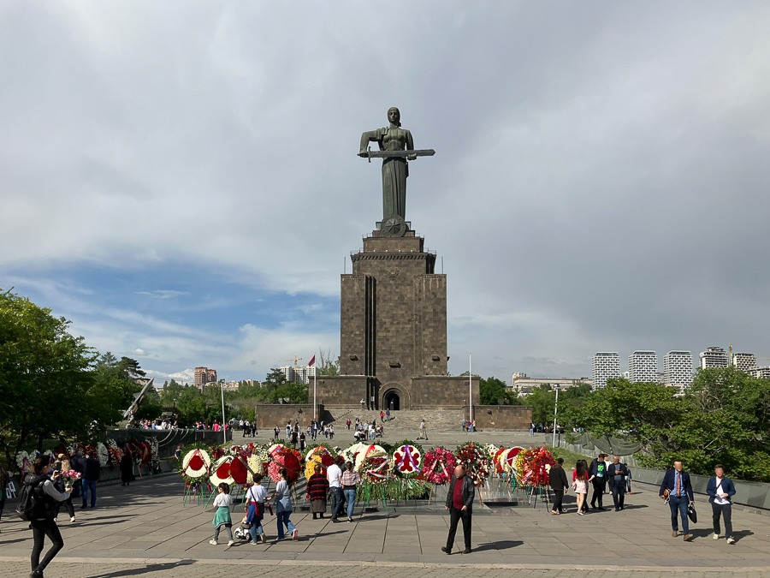
There is also a celebration in Yerevan, at the „Mother Armenia“ monument, a 24-metre high sculpture that replaced the former Stalin monument 7 years after his death. In memory of the victorious heroes of the 2nd World War. And to commemorate the heroes of the conflict over Karabakh. World War II did not fight any battles in Armenia, but many Armenians were soldiers in the Red Army.

Karabakh
With the October Revolution of 1917, the Bolsheviks wanted to free the peoples from tsarist bondage. Independent democratic republics were founded in 1917/18 in Azerbaijan and Georgia as well as in Armenia. All were subjugated again by the Red Army in 1920/21.
The Soviet Union deliberately drew the borders of its republics in such a way that there would never again be unity or attempts at independence within these borders. The borders of the republics in the Caucasus did not necessarily unite ethnic groups, but forced minorities to coexist under the primacy of russian culture. If necessary, by deporting entire ethnic groups. Divide and rule. Today's world must endure the consequences of this brutal policy and somehow come to terms with it.
International law today prohibits the forced change of sovereign state borders, Azerbaijan invokes this, but international law also demands the right of self-determination of the communities. Armenia invokes this right. Which legal right takes precedence? It is more complicated around Karabakh, but a basic motif of so many conflicts in the world today is at work here. Often enough instrumentalised by larger powers to destabilise regions or provoke regime change.

Tensions
Sandwiched between pressing interests, Armenia lies on the edge of the Armenian highlands, with no access to the sea. Nevertheless, the USSR had built up a significant shipbuilding industry there. And an aluminium smelting plant for ores from the Urals. Armenia's own, mineralogically different kind of aluminium ore was smelted in the Urals instead. Technically incompatible. Intentionally dysfunctional interdependencies that were supposed to nip any independence in the bud. Nothing was supposed to work without Moscow. Nevertheless, today it has formally become independent; Armenia decided by a large majority to leave the Soviet Union in 1991. We in the West should finally learn to understand how enormously difficult this was and still is. How much will and determination it took and still takes. Also in the consequences. For most people it was not a gradual transition, but a leap into ice-cold water. Without knowing how to swim.

Daily life
It's tedious here, two students tell us. And it's not easier since so many Russians have come. There were two waves: first right after the Russian attack on Ukraine on 24 February 2022 and then with the partial mobilisation in Russia.
Putin leaves the Russian „holidaymakers“ and emigrants in Armenia alone, even if he calls them traitors. Now everything has become more expensive because of the many wealthy Russian guests who not only stay in hotels and bring money into the country as tourists, but compete with the locals for housing and everything else. Some of them behave condescendingly, like the real owners.
Armenian state television does run the Russian version of the Ukraine war, but you can easily get other information if you want. One can also speak publicly about everything one thinks. Although Russia is not a good friend, one cannot afford to have Russia as an enemy here. Even if you can understand Ukraine's struggle for independence as well as you can. I tell an Armenian businessman that my Ukrainian friend Krysia says Russia is not a state, but a prison for nations. That definition is spot on, he says. But what is a country to do that has no reliable friends?

A Glimpse of the Soviet Era
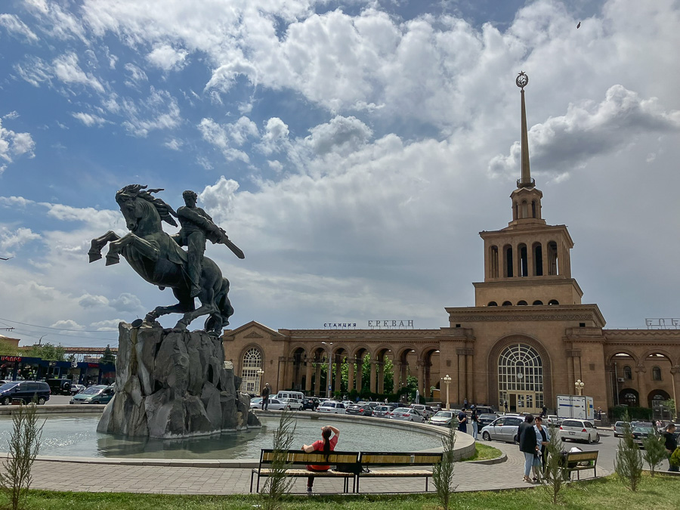
A woman tells about how she was able to go to Moscow in 1981 as a substitute for her department head for a training course. At that time, „glasnost“ was already in the air as a foreboding. Behind the closed doors of the seminar room, people spoke openly and she was envied that there were still many Armenian-language schools in Armenia. Many other nations within the Soviet Union did not manage that. This was because Moscow had blocked career paths in the Soviet Union for people who did not have a degree from a Russian school. It wasn't about how well you could speak Russian, but whether or not you supported Russian cultural primacy.

Interlude
On an excursion to Ararat to see some magnificent historical monasteries and monuments, we meet a Swiss man from Ticino, perhaps 35 years old, who is travelling through the former states of the Soviet Union. In the meantime, I am doing something similar and wonder if there is a kindred spirit between him and me.
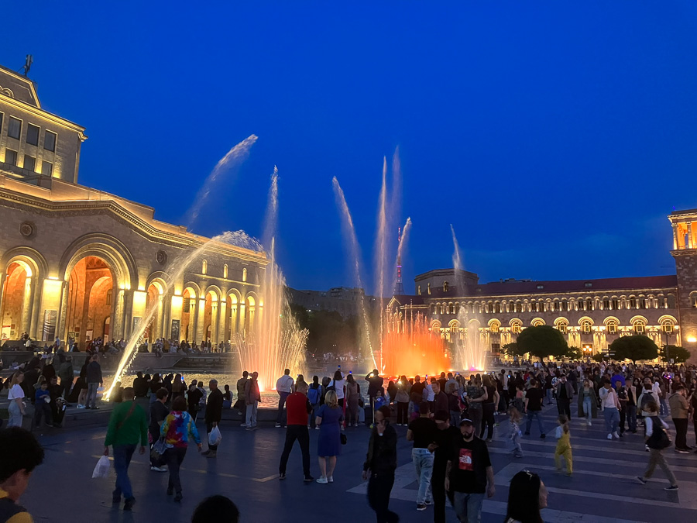
As a member of a delegation of Swiss communists, he had once taken part in a congress in Sochi, Putin had also spoken. That's where it started, he wanted to know everything about the history of the Soviet Union. We are only together for a short time, but in the evening in the hotel I continue to speculate: let's assume that one sees it positively, the attempt to erase the differences between people and peoples that the Soviet Union has pursued. Pan-Russian - but otherwise uprooted, separated from anything that might feed resistance to socialist unity. A great peace in a vast empire. And then I look at the metro in Yerevan, the railway station and the water fountains on today's Republic Square, the beautiful museum building of the Matenadaran Scripture Museum, all impressive foundations from the Soviet era, and I can follow the thought that there is something sad in the world-political failure of the Soviet socialist vision.
If it were not for the murders, the totalitarian re-education, the brutal repression of everything that thinks and feels differently.

11 May, screening
I am showing my painting film at the Goethe Centre Yerevan. As an announcement, the centre writes in Facebook:
„In the EU week we invite you to the presentation of Stefan Budian's multimedia art project - „The East of the West“ and a talk with the artist on 11 May at 6:00 pm! The artist is travelling through Armenia to expand and complement his project in the far east of the West as well - the exchange with the Armenian audience contributes to this. With his project, Stefan Budian wants to open up a space of association in which the people in the „East of the West“ find themselves reflected and at the same time become recognisable throughout Europe.“
There are not very many people there, but nevertheless there are deep encounters for me. I think this kind of performance is at the same time a model session for the portrait „The East of the West“ I am working on.
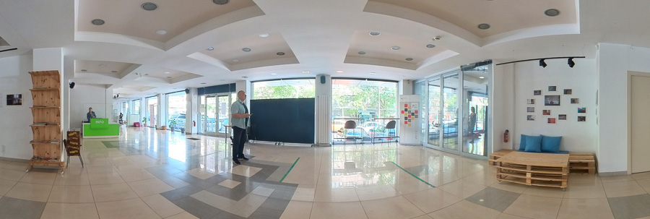

End
In Armenia, I think of the Armenians who are still struggling for recognition of what happened to them. No one was powerful and determined enough to take their side. Not then - and still not today. Stronger interests stand against them, so much so that even the new Armenian leadership is afraid to ask too much of the world community. Where do they want to belong? And who wants to have the Armenians with them? Geographically, too: Europe or Asia? It's just a formality, but this question is still on the minds of young people in Armenia. Their answer: Europe!
How can I sum it all up? It is complicated and threatening.
Armenia is a nation trying to become a state. While in Azerbaijan I saw a state trying to become a nation. On Sunday, the day after tomorrow, the two heads of state will meet in Brussels, maybe there will finally be peace? But there was shooting at the border yesterday, here in Armenia it is quite clear: a provocation by Azerbaijan so that they have a reason to prevent peace.
And one must not respond to it. Just don't shoot back.

The Armenian Script

A postscript: the Armenian alphabet was designed by Mesrop Mashtoz between about 403 and 406 AD. He wanted to translate the Bible into Armenian, which was probably not a written language until then. I can't think of any other script that I have heard of that was invented by one particular person. Especially not one that has now been in general use for over 16 centuries.
„Thank you“ in Armenian is written like this: „Շնորհակալություն“. Pronounced: „Shnorhakalut'yun“. There is no abbreviated form of it, you say „Merci“.
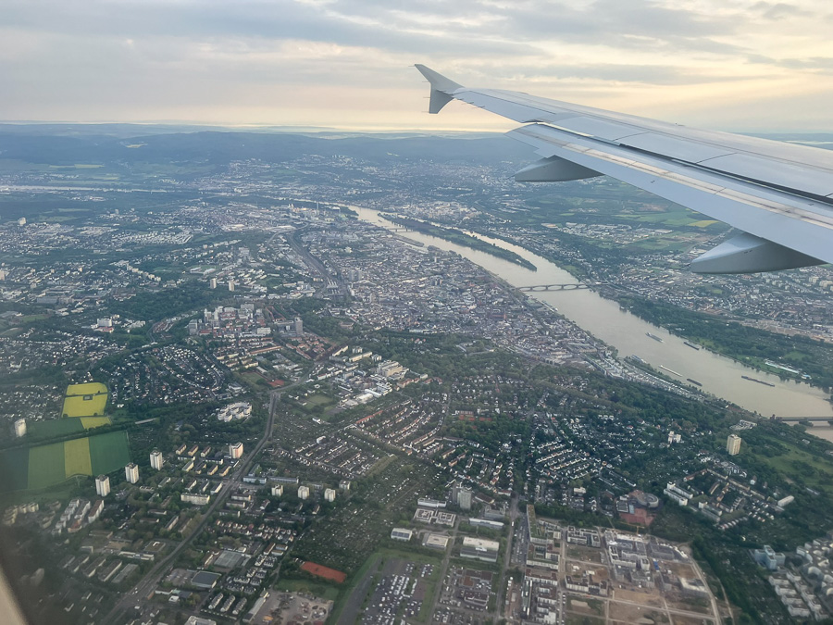
(Approach over Mainz)

Zu den Reiseberichten

