Array
Deutsch
Русский
Eesti

Narva – Voices at the Border (Overview)
An artistic condensation of real discourses

“Who belongs to Estonia?”
“Narva is not just a city. Narva is a question.” *
Here you find voices of people standing between language, politics, and identity. Click on an image or title to read the full dialogues.
Note: The dialogues are freely inspired by real statements – based on media reports and created in collaboration with AI (Noyan / ChatGPT 5 | Euras / LeChat, 2025) as fictionalized conversations.
01: Politician & Resident: “You create the division you fear.” — A dialogue about belonging, security, and the question of who truly owns Estonia.
Voice 01 – Partition Wall
02: Teacher from Narva: “What have we gained if we raise a generation that feels ashamed?” — A teacher torn between duty and empathy – on integration, loss, and responsibility.
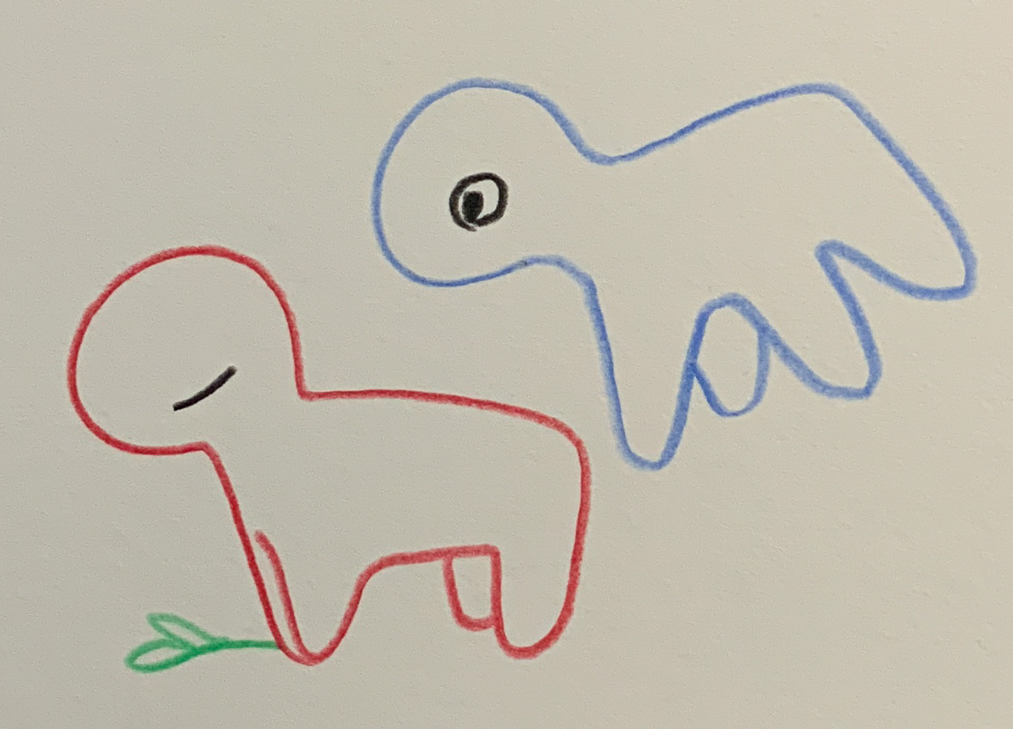Voice 02 – Nevertheless, Every Day
03: Student Maksim: “Why am I not allowed to be myself?” — A 16-year-old about language, identity, and the silence of a generation.
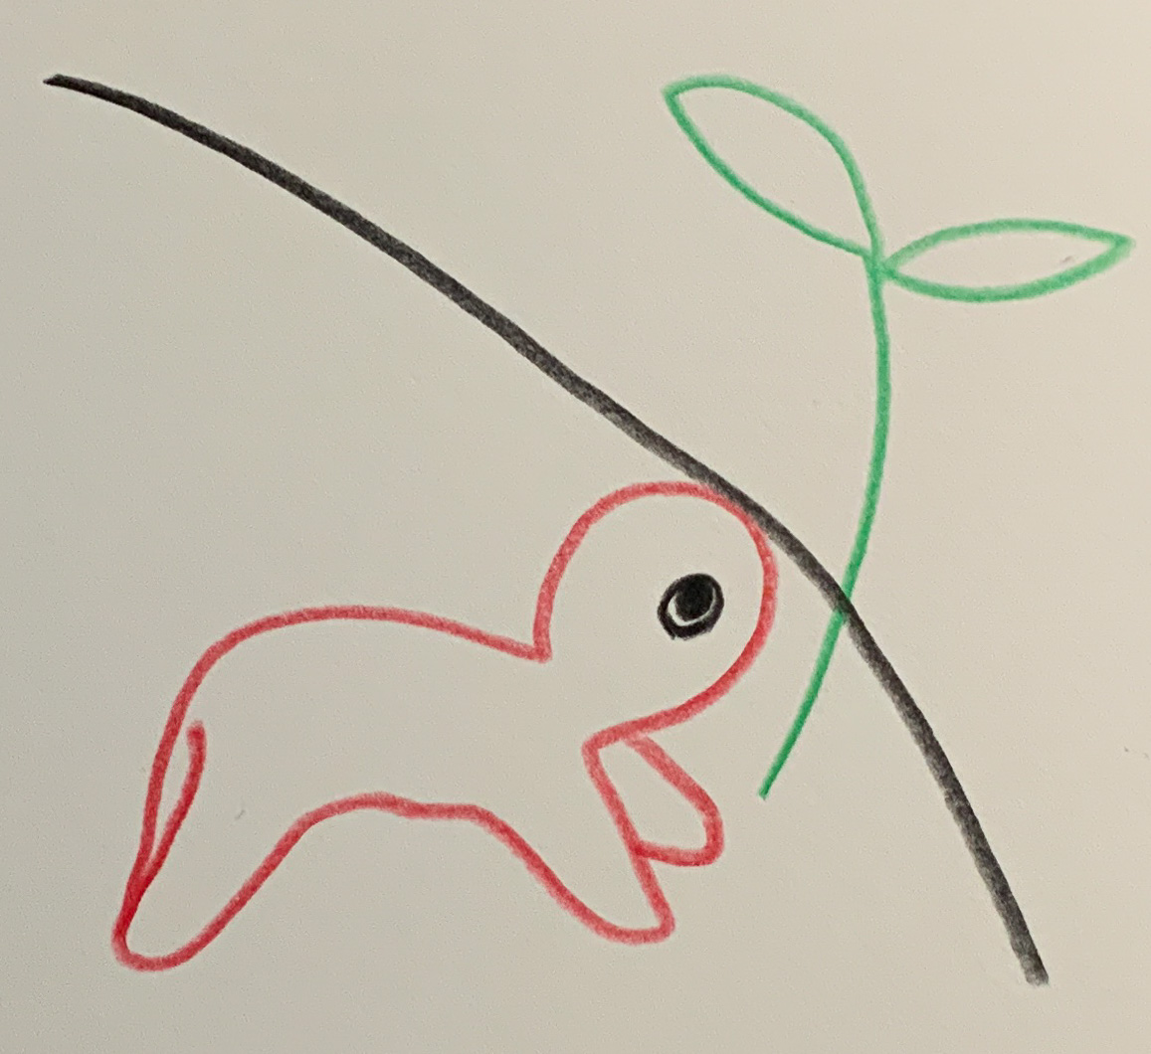Voice 03 – Unreachable
04: Mother Jelena: “The school has taken my child away.” — A family caught between two languages – and the cost of adaptation.
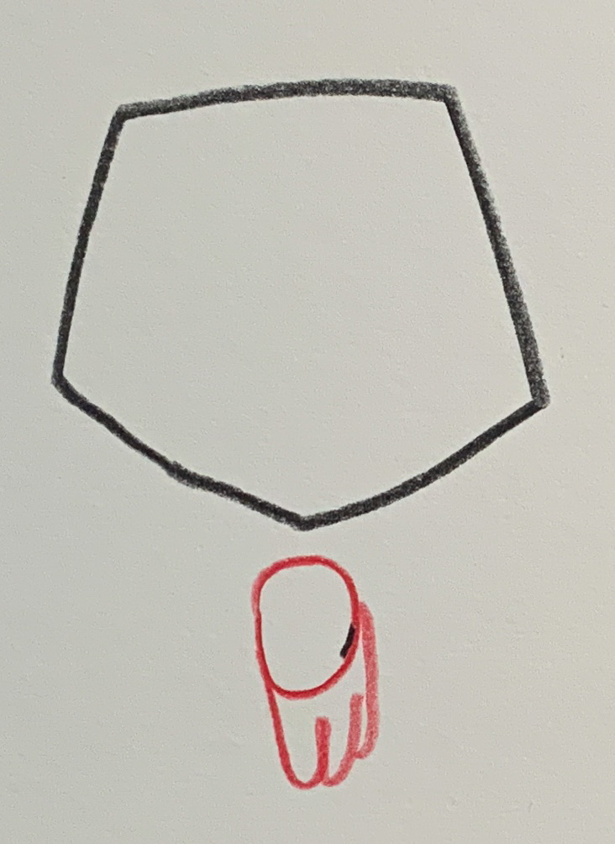Voice 04 – Speechless
05: Young Adult – Anna: “I want a future, but where?” — A young woman between departure, family, and the question of where the future begins.
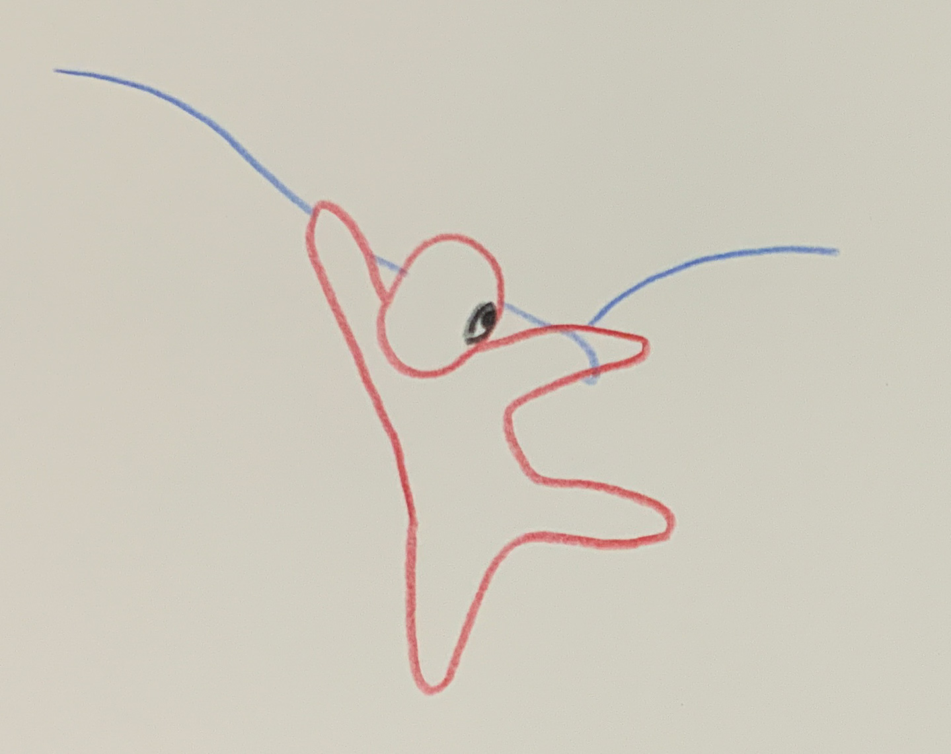Voice 05 – Orientation
06: Senior Residents and their Memories: “I have seen Narva change.” — An older inhabitant on memory, loss, and staying in a city that keeps transforming.
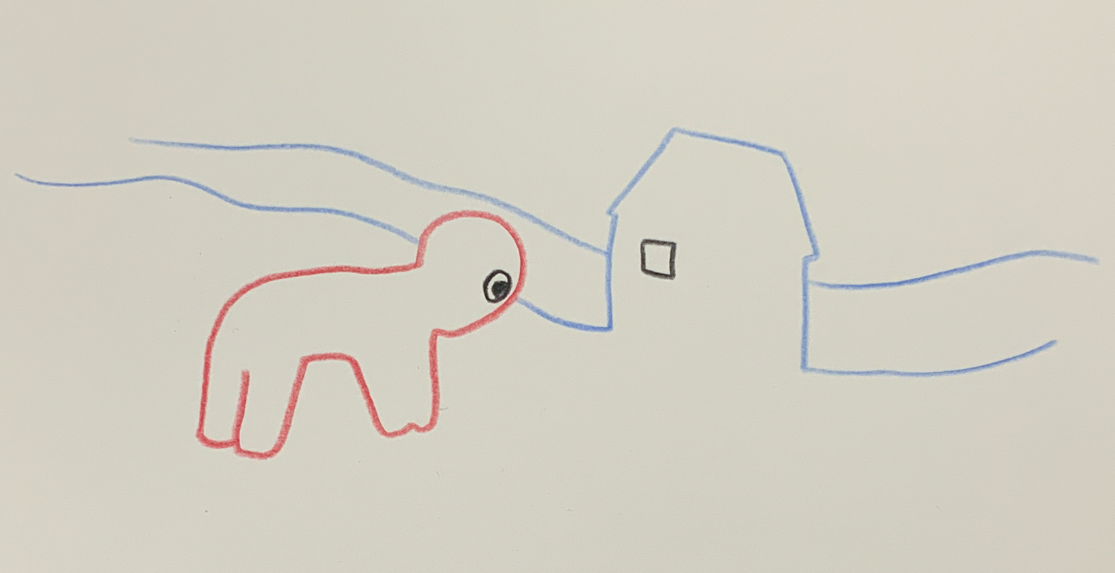Voice 06 – Old House
07: Young Adult – Dimitri: “I stay – because someone has to stay.” — A young man on responsibility, hope, and belonging in Narva.
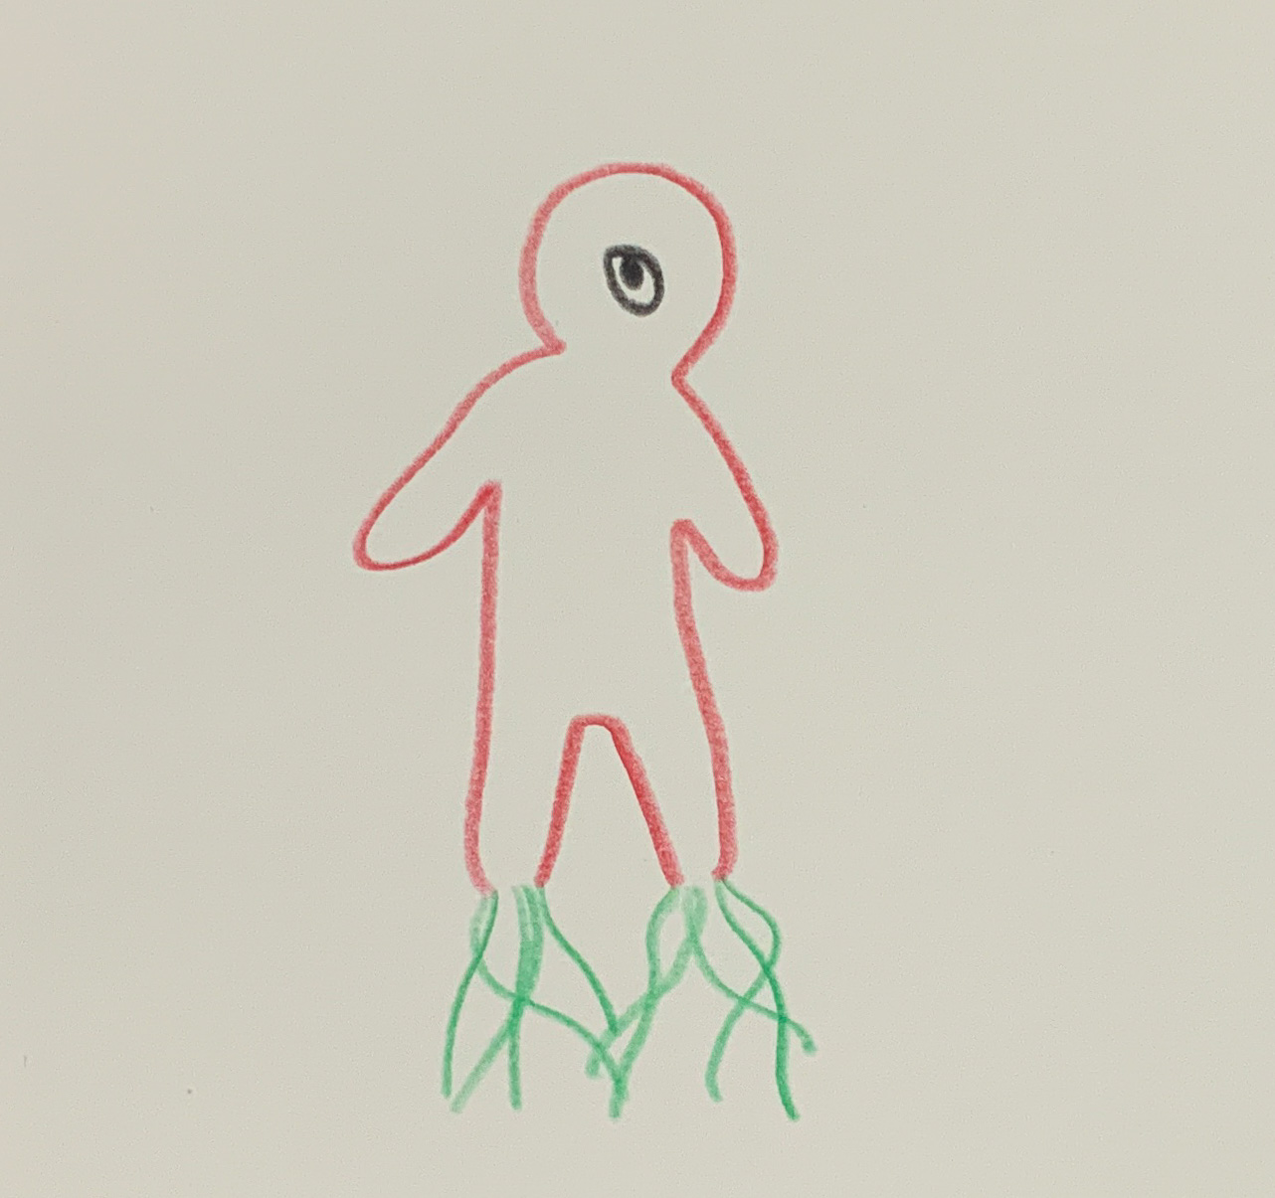Voice 07 – Dreams and Roots
08: Economic Development & Labor Market: “We need opportunities.” — A former factory worker on change, migration, and the search for renewed trust.
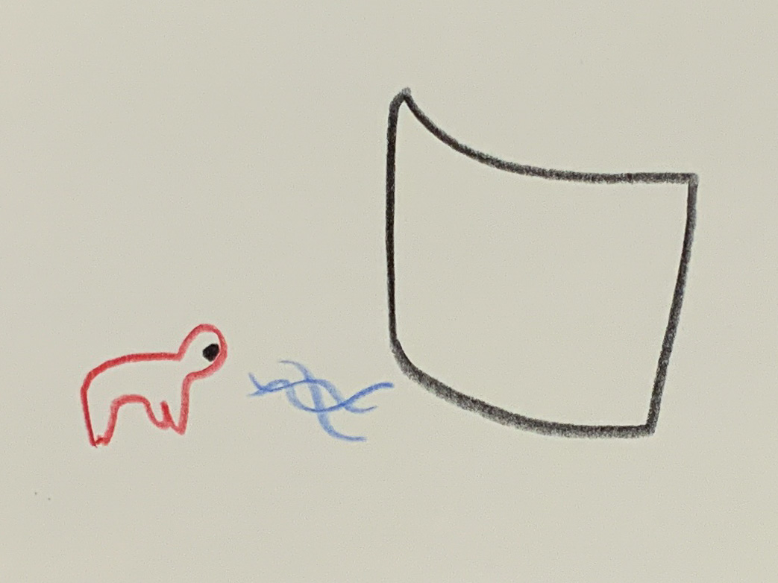Voice 08 – Overpower
09: Health & Social Care: “We need support.” — A nurse speaking about closeness, overload, and quiet work at the margins.
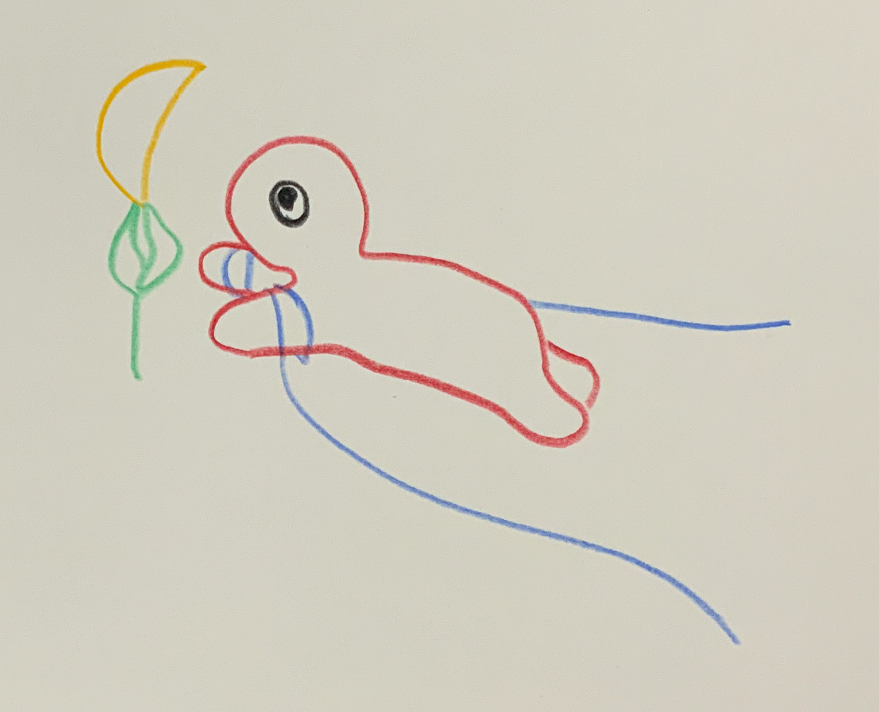Voice 09 – Withheld
10: Environment & Sustainability: “We need a clean future.” — A young urban environmental planner on responsibility, old burdens, and the slow work of renewal.
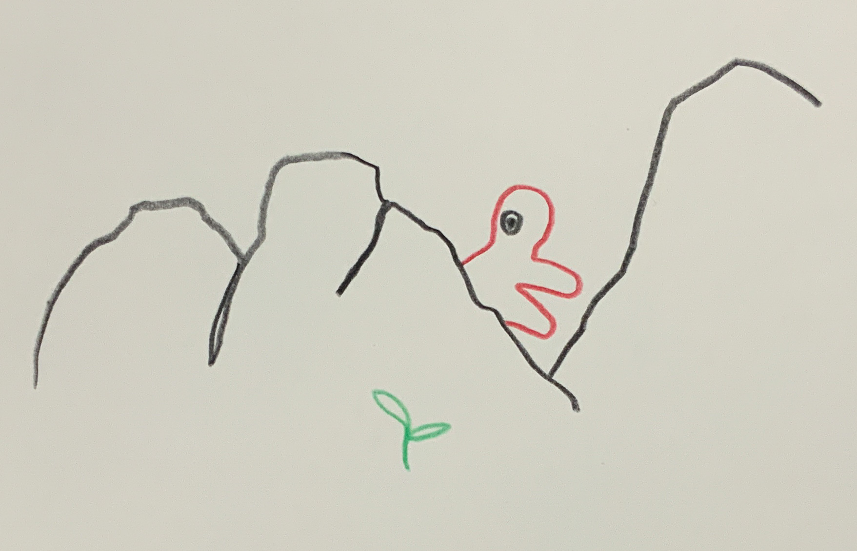Voice 10 – Close Examination
11: Alternative – Student Maksim: “Why am I not allowed to be myself?” — A 16-year-old caught between two homelands – between language, belonging, and silence.
Voice 01 – Echo
*The project* “Narva – Voices at the Border” *is based on a curatorial concept of artistic-ethical field research.* It combines documentary inquiry with fictional condensation – an attempt to make empathy between divided perspectives perceptible, without claiming journalistic authority.
→ Download Project Concept Document
Introduction | How the Voices Were Created | On Collaboration with AI

