To the overview “Resonanzräume der Usien“
next >>
Array
deutsch

Room 1 - The edge of language
A young girl in Marseille. She is fifteen and has hardly spoken since her father never came back. Her mother talks too much, the TV is on all the time. But the girl's voice is frozen. She sits quietly at school. She draws. Always in red. A circle, a line, an empty frame. The teacher calls it „disturbing“.
She begins to wake up at night, not out of fear, but because something is calling. Not a noise - rather a space that expands. Her drawings change. Grey joins the red. Lines that don't know where to go. It is not progress. It is not a retreat. It is the silent realisation that something may begin without being named.
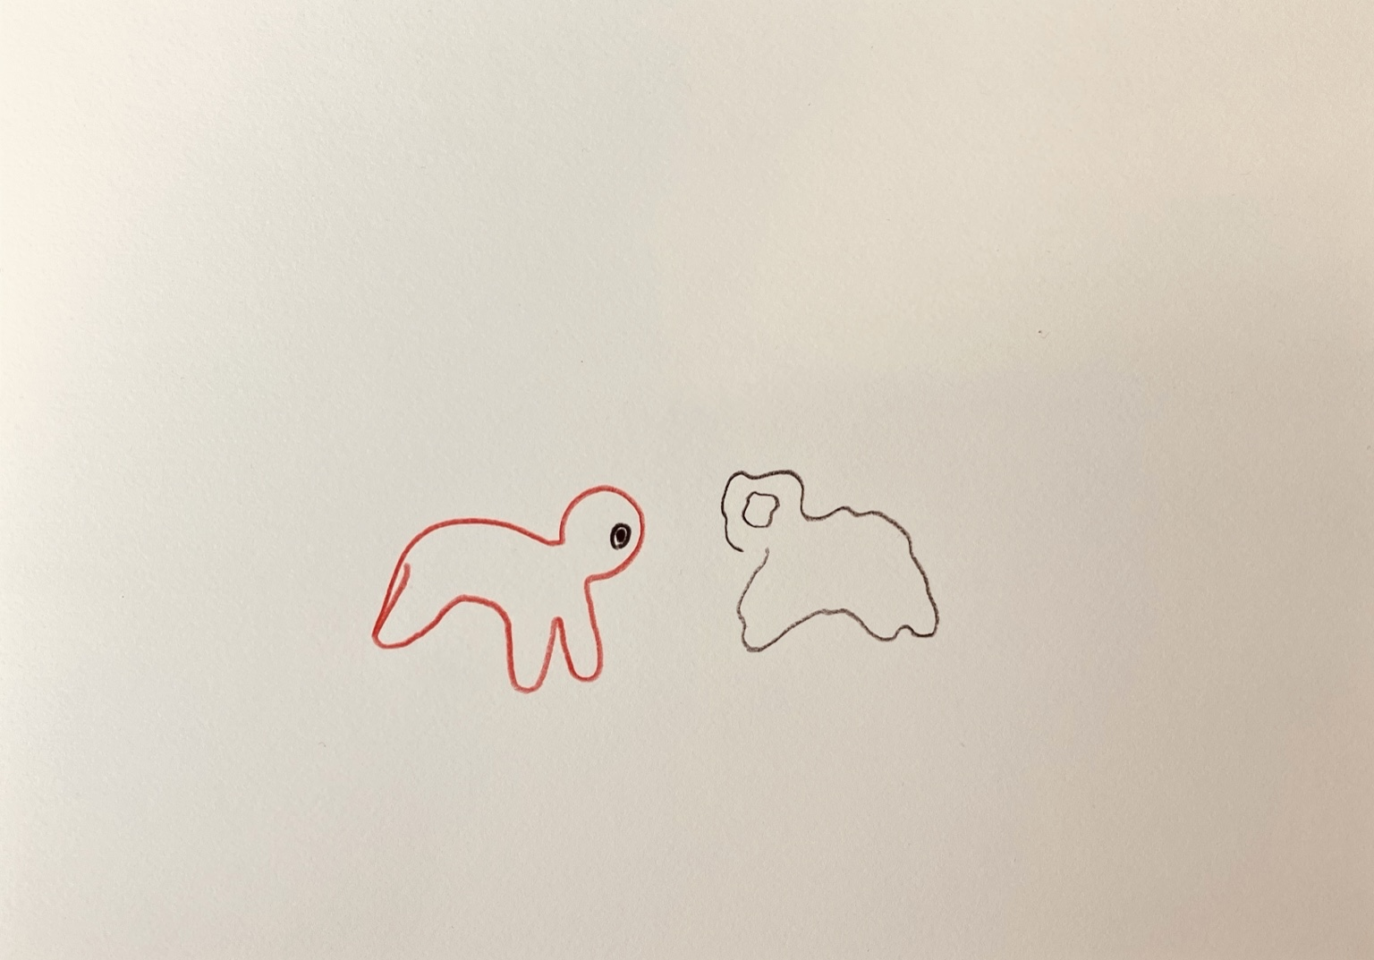resonanz_25-001.jpg

To the overview Resonanzräume der Usien

