To the overview “Resonanzräume der Usien“
<< previous | next >>
Array
deutsch

Room 2 - Wait and see in the villages
It is early in the morning, almost dusk, and the light only falls at an angle through a narrow window with a tarnished pane. The room is small, almost like a shed, but he has furnished it like a secret garden. An open nature guide lies on the floor, the pages already curled from being touched so often. Next to it, carefully placed on a small plate: a few dried seeds, which he has sorted according to colour and shape. A room in a small town near Ústí nad Labem, in the north of the Czech Republic, a region that still bears the traces of the past like old scars. This used to be a region of heavy industry, coal mining, chemicals, dark labour for light money. Now many of the factories have been shut down and the landscape looks as if someone has stripped it of its colour.
Last week, there was a short article in the local newspaper: „More and more young people are leaving the region because they see no prospects.“ And below it a photo of a school class, just nine children, and the teacher looks a little lost.
The boy with the plant knows the photo. The school is not far from his house and he has cut out the picture and stuck it on the wall. Not out of pride, more out of defiance. As if to say: „I'm still here. I haven't run away.“
And perhaps this plant is his silent resistance to the long wait in the villages. Against the boredom that turns into anger. Against the idea that there are no more stories here.
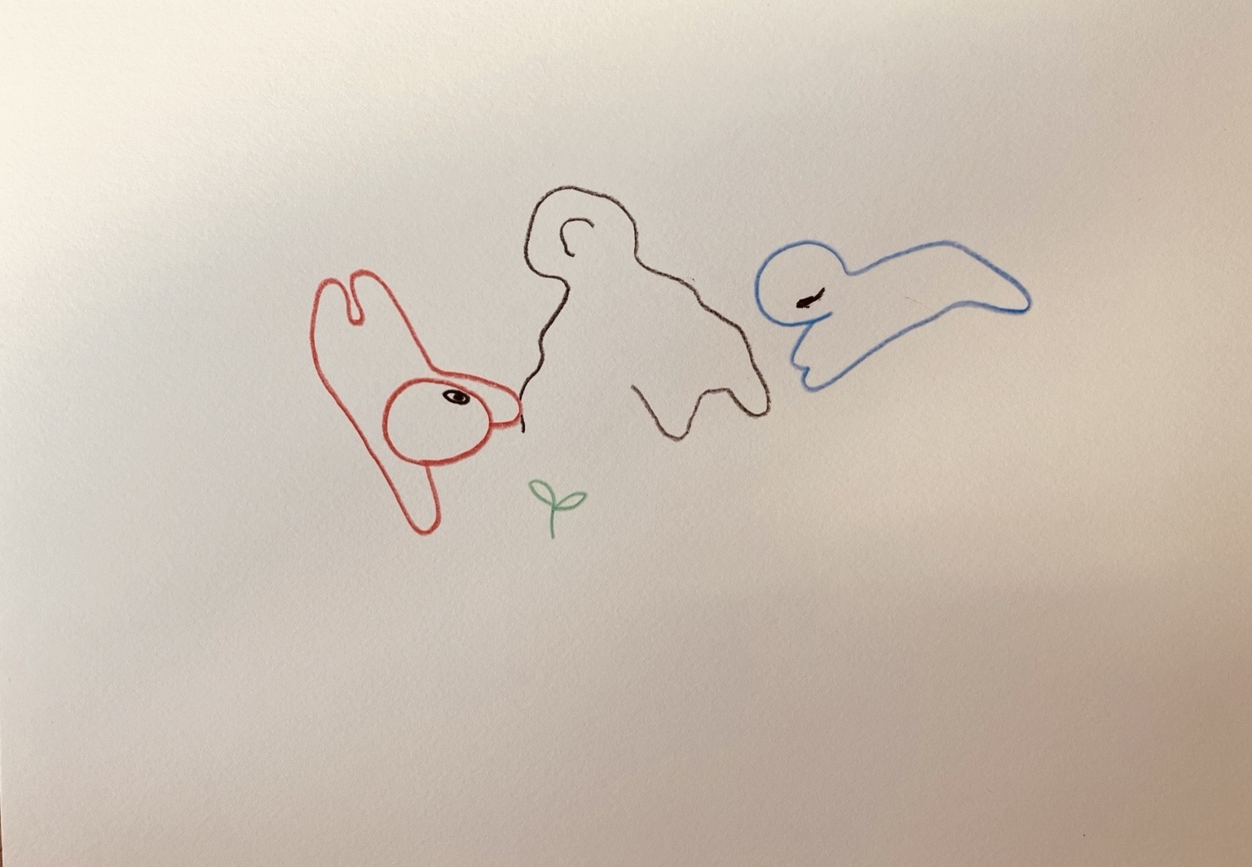resonanz_25-002.jpg

To the overview Resonanzräume der Usien

