To the overview “Resonanzräume der Usien“
<< previous | next >>
Array
deutsch
polski

Room 9 – Jakub under the Banners
Warsaw, June 4, 2023. The sky is clear, the sun is mild, and yes – it really is millions. Some say: the biggest crowd since ’89. Others: just a symbol. But Jakub stands in the middle and doesn’t count. He’s 26, works in a copy shop in Mokotów, studied philosophy but never finished – his father said, “How do you expect to live? Off of thinking?” Everything’s felt sticky for months. The news, the neighbors, the election posters, his girlfriend’s voice saying, “You can’t change anything anyway.” Jakub believed her. But today, he joins. There are really many. And it’s loud. Drums, chants, flags, posters with hearts, with rage, with hope. Jakub doesn’t speak. He carries no sign. But he feels something: A lift inside. An inner rising, not pride, not defiance – more like the moment when a bird stops moving its wing and still flies. A child walks beside him. Cardboard wings on its back. It says, “I’m a starman.” Jakub smiles. The child loses sight of its father. He takes its hand. Later, after the march, he won’t remember which slogan reached him, which speaker was good. Only this: that he no longer felt alone under the weight of helplessness. In the evening, a sentence takes root in him: “When millions breathe at once, even the quietest one is lifted.”
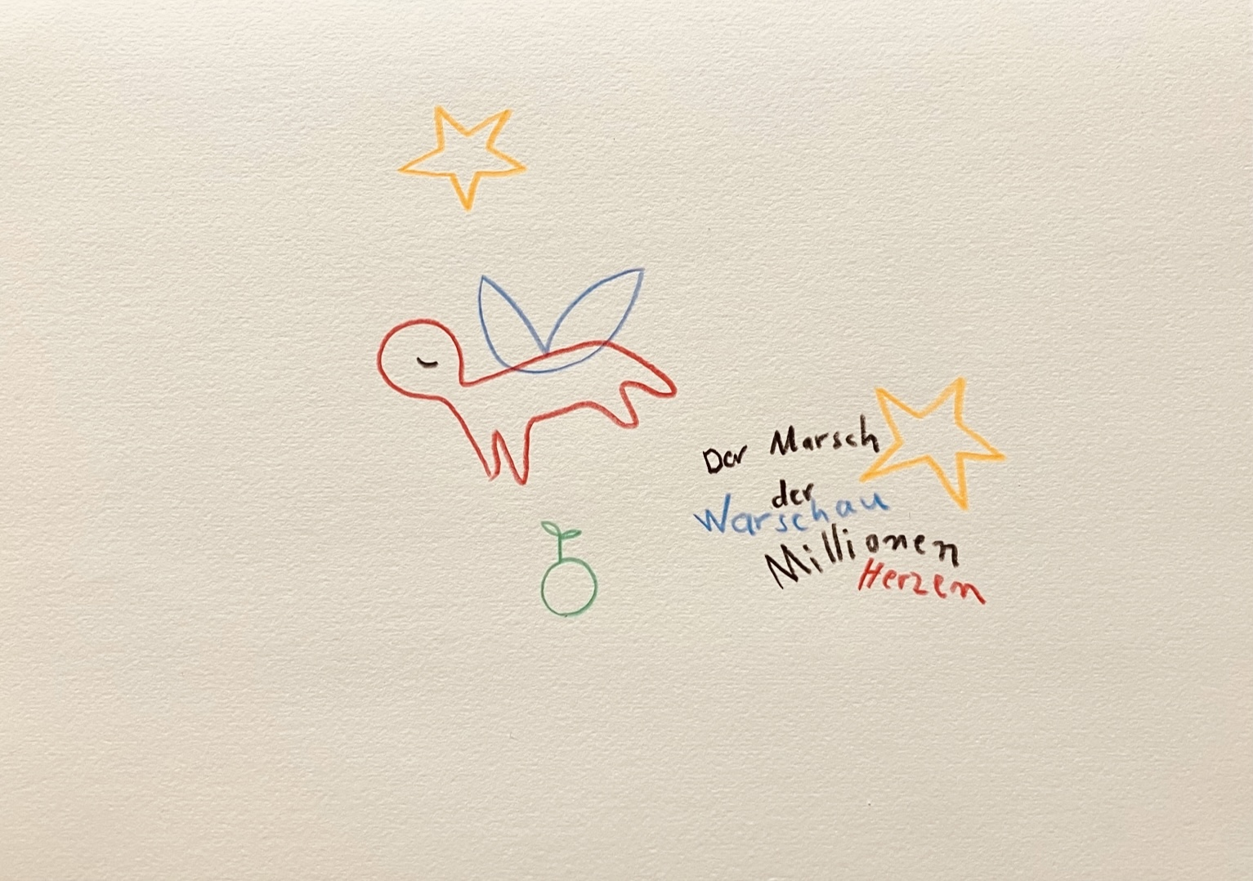resonanz_25-009

To the overview Resonanzräume der Usien

